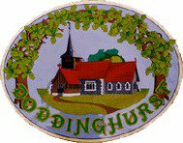 Doddinghurst Parish Council
Parish Office (adj. Village Hall)
Church Lane, Doddinghurst,
Website: www.doddinghurst-pc.gov.uk Brentwood CM15 0NJ
Telephone 01277 824245 e-mail: clerk@doddinghurst-pc.gov.uk

Introduction

Welcome to the Spring/Summer issue of the Parish Council Newsletter which includes the 2022/23 Annual Report.

After the cold winter it was lovely to see Peartree Pond looking so colourful with daffodils in full bloom.

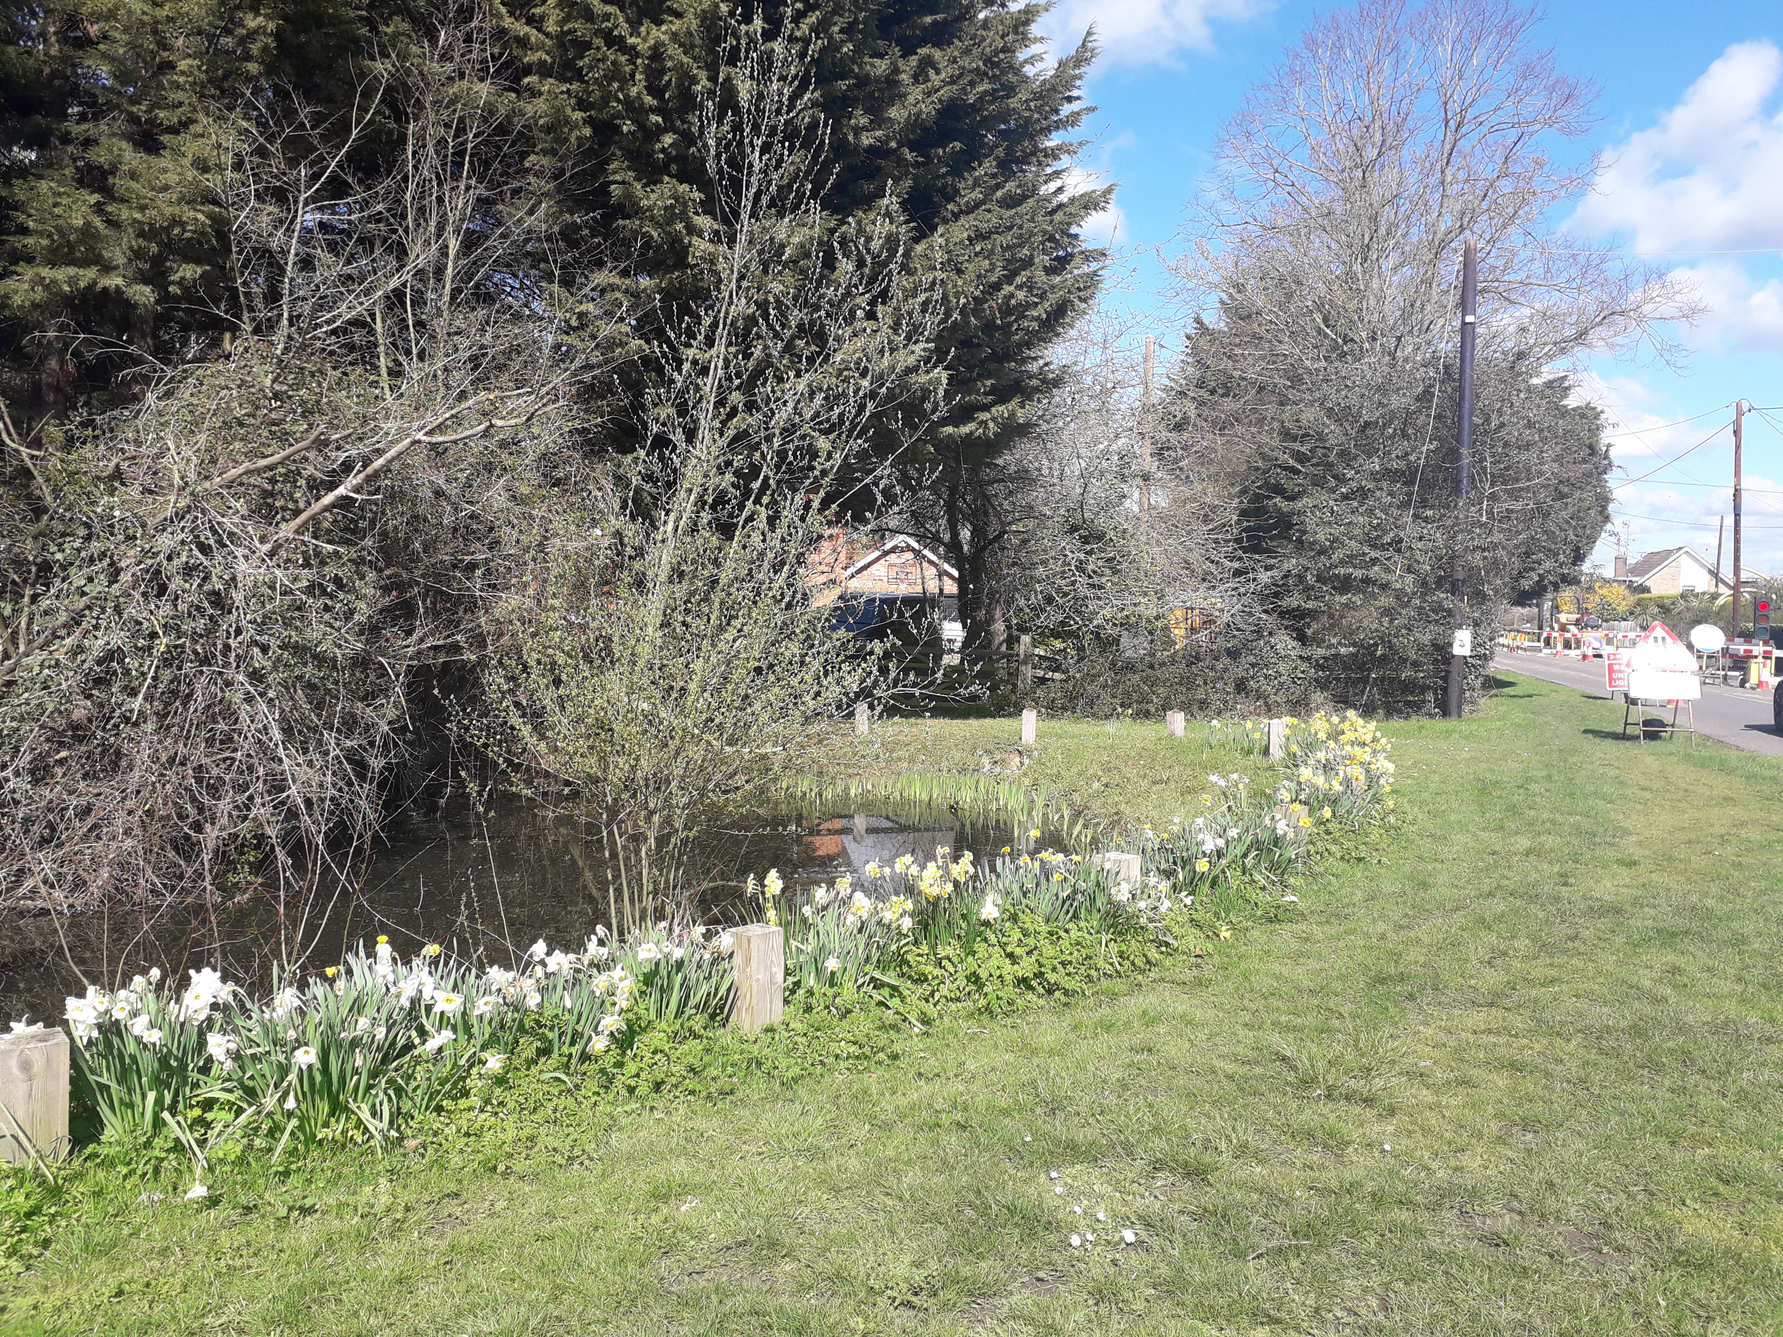

New Website & Social Media

The Parish Council’s new website is now up and running. There is also a Facebook page Doddinghurst Parish Council. The office also regularly post on the Doddinghurst Discussion Page to update parishioners.

2023/24 Council Chairman

At the Annual Council Meeting held on 11th May, Cllr Debbie Dicker was elected to continue as Chairman.
Details of all serving Parish Councillors are available on the website or via the office.

Parish Council Meetings

Upcoming meeting dates are:

- June 14th – General Purpose
- June 29th – Planning*
- July 6th - Full Council
- July 27th - Planning*
- Sept 7th – Full Council
- Sept 27th – Planning*
*Subject to change

Minutes of meetings can be found on the Parish Council website.

Parish Councillor Vacancy

There is a vacancy and further details can be sought from the Parish Clerk. Please note this is a volunteer position and will require attendance at regular evening meetings.

Page 1 May 2023 Doddinghurst Parish Council

Coffee & Cops – Parish Room

On 14th June at 1pm the Parish Council will be hosting a session with PC Madeline Payne. Members of the public are welcome to attend and raise matters of concern.

Cllr Katie Pond

The Parish Council and staff would like to thank Katie for all her hard work during her time as a Parish Councillor.

King’s Coronation

Cllrs Dicker and Le Page once again organised a family afternoon on behalf of the Parish Council.

The weather was extremely kind and the sun shone. Families came from all over the village and other parishes to enjoy the bouncy castles
and entertainment. Everyone enjoyed the day and compliments came from everyone attending.

A big thank you to all the helpers, and to the village hall for their usual support.
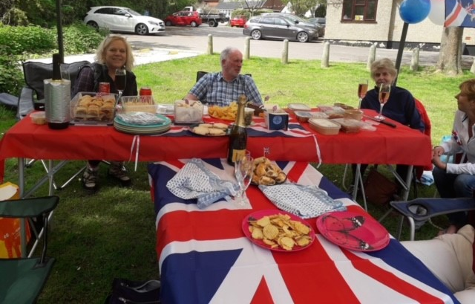

Memorial Plaques

Brass plaques are available to order. These are placed on the circular memorial plinth at the Cemetery.

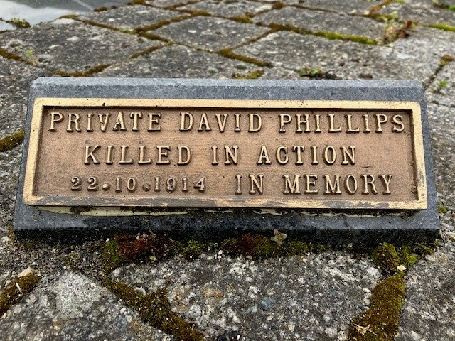

Village Bus Trips

The Parish Council continues to support the Village Bus service. All trips are advertised on the Parish Council website and notice boards.

The planned trips for 2023 are:-

24th July – Southend
16th Aug – Colchester
25th Sept – Van Hage Garden Centre
18th Oct – Bury St Edmunds Market
22nd Nov – London light & West End
5th Dec - Bluewater

The trips are only possible due to the commitment of volunteer drivers. If you are interested in becoming a driver, please contact the Parish Clerk for details.

Allotment Plots
All plots are currently rented out. If you would like to be added to the waiting list, please contact the Parish Office.

nnn

Page 3 May 2023 Doddinghurst Parish Council

ANNUAL REPORT 2022/23

What a difference a year makes - last year we were still suffering from the effects of Covid, now we seem to be free and enjoying life once again.

The Parish Council has finished refurbishment of its offices and this makes a great difference for those who work and visit there.

The children’s play area is very busy as usual, and the new trainer has now been installed. Our fields and grounds together with the burial ground are now looking great. Let us hope for a pleasant summer.

As you are aware, we have had serious problems with youths in the village. The police have of course been informed and a private security company has been used. It is a great sadness that a small group of young people can do so much harm, in a lovely community. We are looking at new ways to secure buildings but it is up to all of us to help with making these young people behave.

The 61 bus is working well, and has a contract until next June 2024. I am very involved with keeping up with the bus and the contractors who run it. If you do have a problem, please let me know.

The more the bus is used it will make Essex County Council realise how important it is to the village.

Unfortunately, our Deputy Clerk Clarrie left for pastures new but we wish to thank her for her hard work and wish her well.

I am pleased to say that we have taken on a replacement Deputy Aimi Davies, who is very qualified, and we hope she will be happy with us.

We are asking our County Councillor to look at our roads and pavement, some of which are in bad condition. The double bends and Doddinghurst Road were repaired last year but unfortunately, potholes have already appeared.

The Parish Council, is here to help residents, as I say every year, this is your parish council, and we are here to serve you.

I hope you have a good summer.

Debbie Dicker
Chairman

Page 2 May 2023 Doddinghurst Parish Council

2022/23 ACCOUNTS

 | 2021/22 £ | 2022/23* £
Band D per household | £63.39 | £63.39
Receipts
Precept | 113,921 | 37,907
Cemetery/Allotments | 18,152 | 14,621
Other income | 1,711 | 3,624
VAT refunds | 5,205 | 6,859
Interest | 41 | 329
Total receipts | 139,030 | 63,340
Payments
Office/Staffing | 62,342 | 88,274
Cemetery/Allotments | 6,392 | 5,940
Outside spaces | 12,545 | 11,626
Loan repayments | 7,564 | 7,564
Total payments | 88,843 | 113,404
Balance c/f | 149,287 | 199,474
Receipts | 139,030 | 63,340
Payments | 88,843 | 113,404
Balance | 199,474 | 149,410
Represented by
General Reserves | 79,475 | 49,410
Earmarked Reserves | 120,000 | 100,000
*Unaudited. For a detailed copy of the accounts please contact the Clerk.

Parish Council Officers:

Caroline Fuller
Clerk & Responsible Financial Officer

Aimi Davies
Deputy Clerk

Parish Office (adj. Village Hall)
Church Lane,
Doddinghurst CM15 0NJ
Telephone: 01277 824245

Email: clerk@doddinghurst-pc.gov.uk

Parish Council Website
www.doddinghurst-pc.gov.uk

Doddinghurst Parish Council
Councillors

Cllr Mrs. D Dicker (Chairman)
68 Lime Grove
Doddinghurst
CM15 0QY Telephone: 01277 823410

Cllr Mr. P Arnell
Treble F, Brook Lane
Doddinghurst
CM15 0RT Telephone: 01277 822240

Cllr Mr. M Capon
11 Peartree Lane,
Doddinghurst
CM15 0RR Telephone: XD

Cllr Mrs T. Brooks
Doddinghurst House
Place Farm Lane
Doddinghurst
CM15 0HZ Telephone; XD

Cllr Mrs. J Le Page
Sans Souci, Doddinghurst Rd.,
Doddinghurst,
CM15 0QU Telephone: 01277 822867

Cllr R. McCheyne
Pettits Farm
Mountnessing Lane
Doddinghurst
CM15 0RR Telephone: XD

Cllr Mr. D Potter
65 The Gardens
Doddinghurst
CM15 0LX Telephone: XD

Cllr Mrs. D Rogers-Harrison
16 Harpers Lane
Doddinghurst
CM15 0RL Telephone: XD

Cllr Mr. G V Smith
25 Park Meadow,
Doddinghurst
CM15 0TT Telephone: XD

Cllr Mr. A Smith
24 Peartree Lane
Doddinghurst
CM15 0RP Telephone: XD

Vacancy

Page 4 May 2023 Doddinghurst Parish Council

