Members of Doddinghurst Parish Council’s Allotment Committee are requested to attend a Meeting of the Allotment Committee to be held on Wednesday 8th February 2023 @ 13.00 in the Parish Room, adj. Village Hall, Church Lane, Doddinghurst.

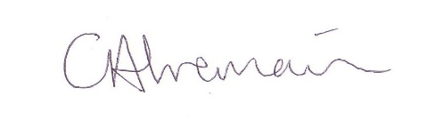

Clarrie Tremain

Deputy Clerk, Doddinghurst Parish Council 1st February 2023

**A G E N D A**

1. **Apologies for absence**
2. **Declaration of interests in items arising on the agenda**
3. **Minutes of last meeting held on 24th May 2022**
4. **Information : Finances**
5. **Resolution : Renewal Fees – Deposit Suggestion**
6. **Resolution : Skip for 2023**
7. **Information : Waiting list update**
8. **Resolution : Date of next meeting/ inspections**
9. **Any other urgent business (no resolution/action required)**